**M4- Suggest potential improvements to a control system**

**Introduction**

In this task I will be suggesting potential improvements to my robot which is in fact the control system. I will be talking about the problems we faced as a group when building this specific robot. Finally I will talk about the comparison between the planning stages and what we thought the robot would have been like to how the robot actually came out.

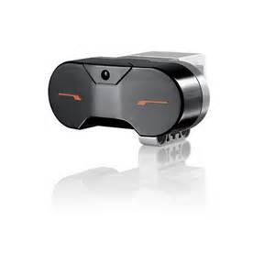After we completion of building the robot we tactically chose the robot which is called the raptor. We then we had some small problems with the first sensors which is called the infrared senor and it was located in the front of the robot itself When we tested this specific sensor we had problems since we couldn’t make this sensor attack forwards. Firstly the robot was only moving forwards and when we put our hand in front of it and it wouldn’t attack at all. We had expected in our planning stages that when we put our hands in front of the infrared sensor then the robot attack rapidly. We did a trial and error for a long time so that this specific sensor would attack when something was in front of it. We first put this in our program and downloaded to the robot itself and saved this step so it wouldn’t be forgotten. Finally we took a video showing this sensor that it worked perfectly

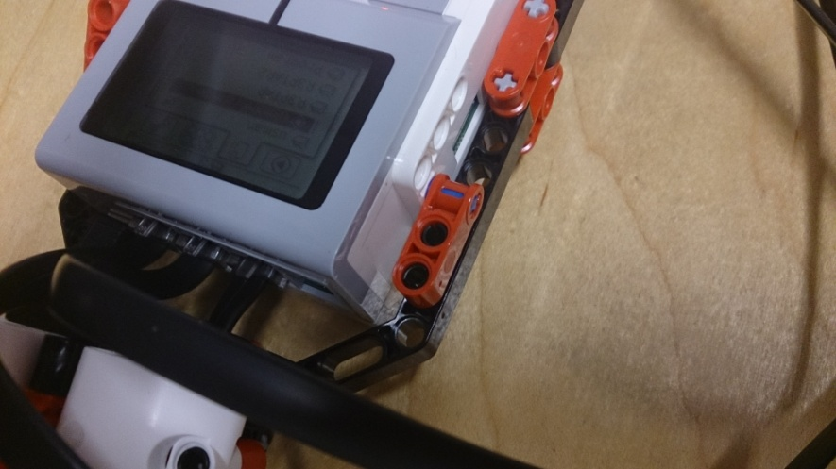We also made other improvements within the robot itself and one example of this is the fact we changed the brick of the robot. When we were building our robot we used our original brick and this brick was attached to the other Lego building blocks so it can be supported. When we finished building the robot then we tested if the brick was working and it didn’t so we had get rid of the original brick and take apart the Lego which was supporting and add a new one which eventually worked. This took time since we thought firstly the batteries were dead and other problems but we found out after investigating our brick we knew we needed to get a new brick immediately

Another improvement we made within the program itself. When we build our robot we needed to go to next step which was set instructions within the program itself. At first the program was running smoothly and it didn’t have any problems. But after we found out that some of the program that we wrote wasn’t getting saved within the robot we created. This was problem because we thought that some of programs we wrote were wrong in it self so we deleted the program and we write it again. This took a hefty amount of time and we did a lot of investigation within the program and one thing we did was that we re opened the program itself so it can be refreshed. Finally we found out that we was using all the right program for the corresponding function so the program was going round in a loop and it was always getting stuck.

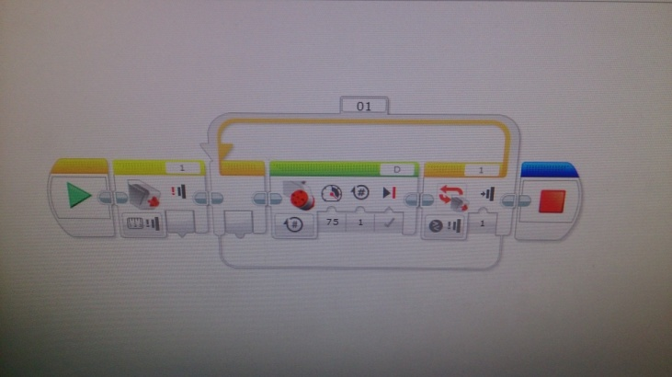

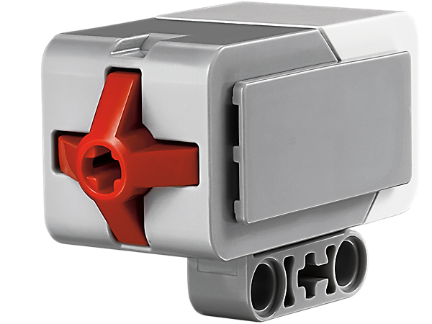Finally the last improvement we made within the robot itself. When we completed programming the first sensor then we tried attaching the second senor which is the touch sensor. This touch senor was hard to put in our robot and we needed imagination so we can attach to somewhere it will fit and can be tested very easily. It took us a long time to this part since we needed extra Lego pieces to fit this specific. Eventually we added it to the right place but we didn’t know what to use this specific sensor for. It took us a lot of time to think about and we conclude that the touch sensor will stop the whole robot for a brief moment. So we should have planned this part of the task out so it will be easier and save a time as well.

